Matthew Zaldana

SID: 027008928

1. Screenshot of ‘ifconfig’ command
   1. Ubuntu Server  
      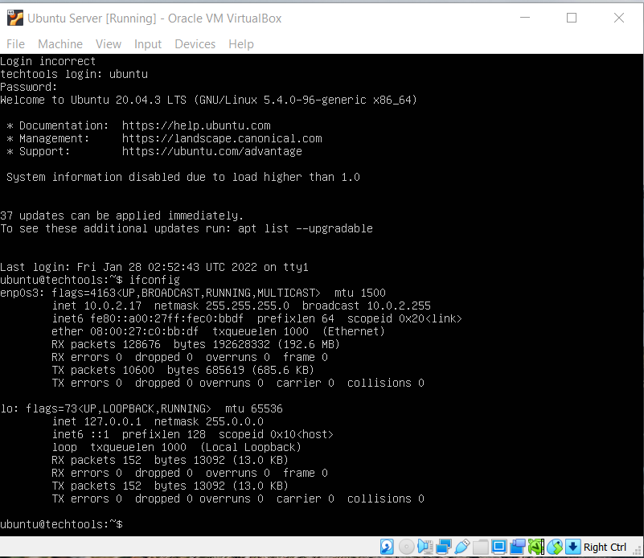
   2. Ubuntu Desktop  
      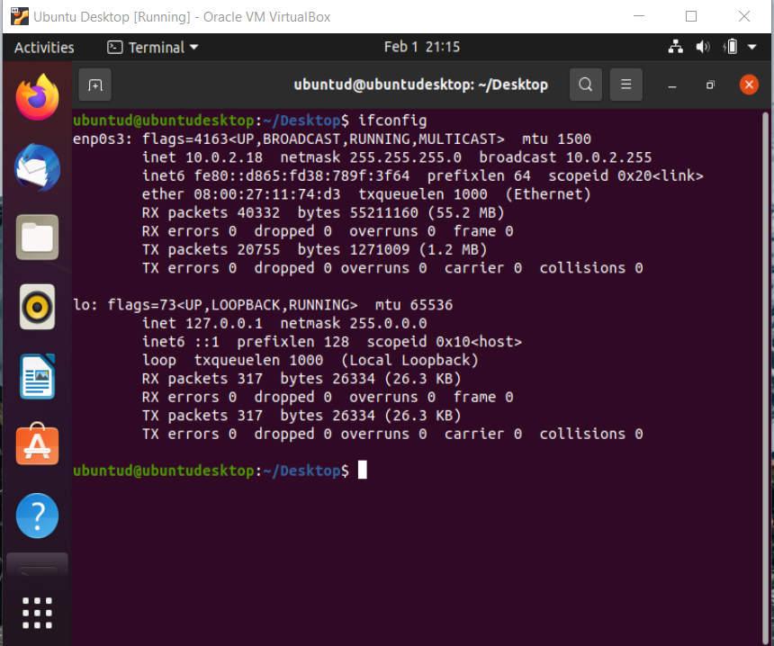
2. Screenshot of each host pinging each other
   1. Ubuntu server  
      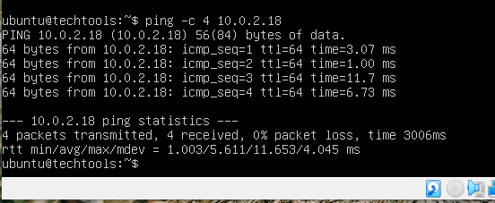
   2. Ubuntu desktop  
      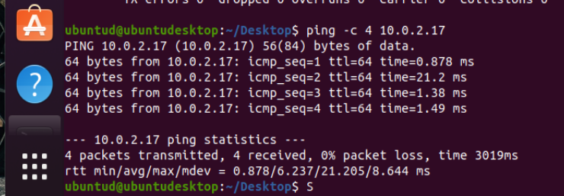
3. DIG command
   1. MX record  
      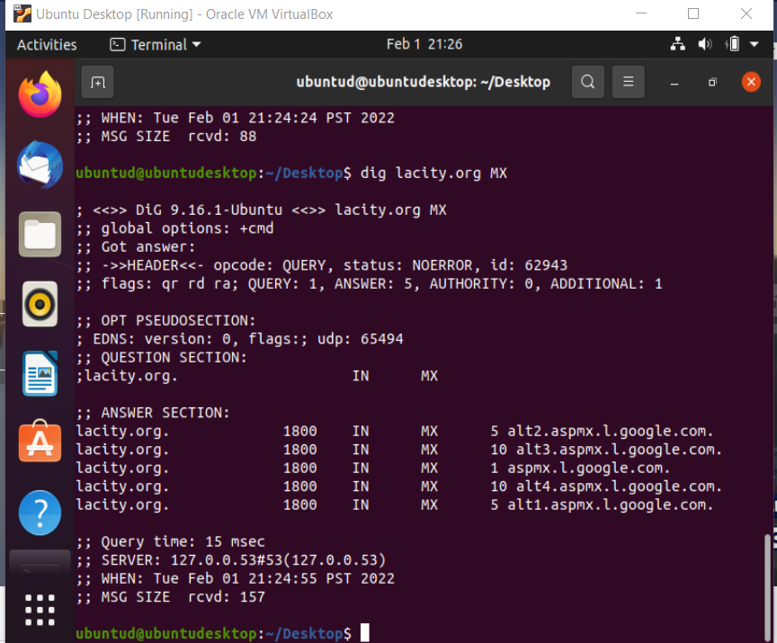
   2. Reverse DNS   
      